EU and FAO deliver livelihood assistance to

flood-affected Serbian farmers

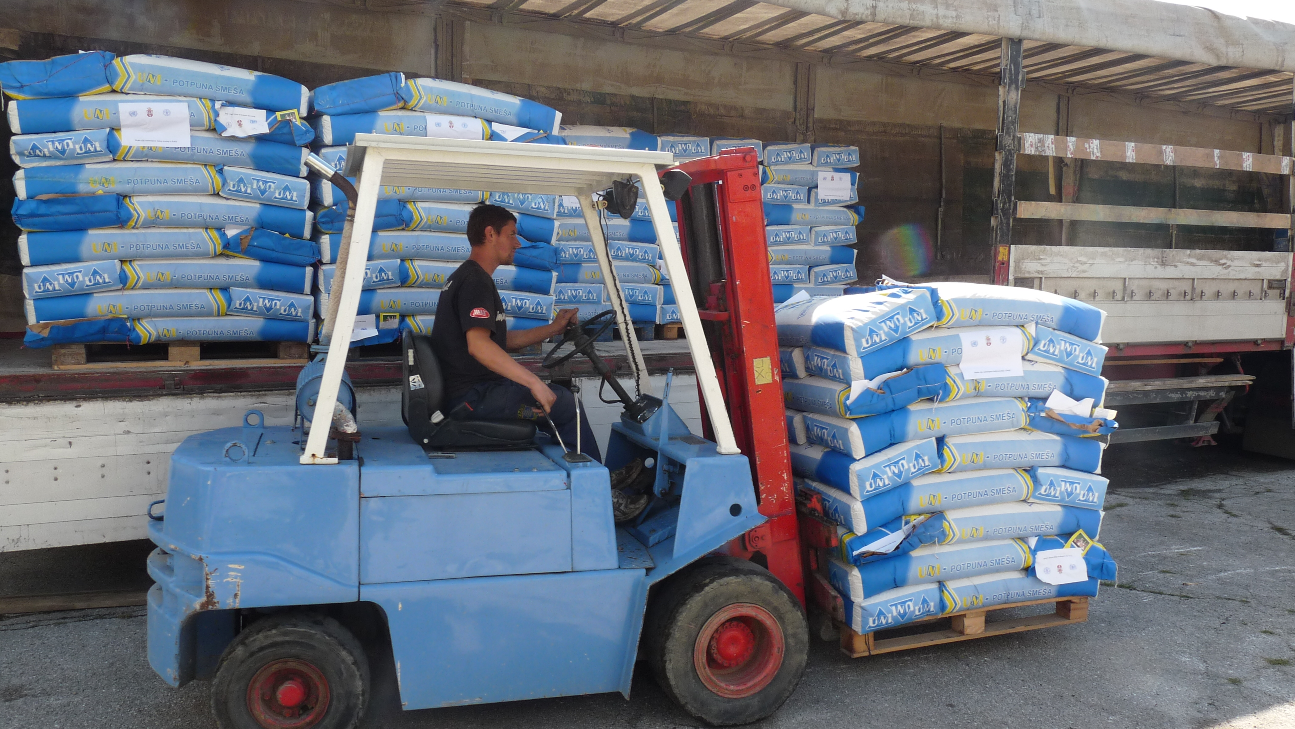

Photo: ©FAO/M. Bozic

3 September 2014, Trstenik, Serbia – European Union assistance to flood-affected Serbian farm households got under way with a first delivery of animal feed here today. Financed by the EU and delivered in partnership with the UN Food and Agriculture Organization (FAO), the assistance forms part of the EU’s overall flood recovery package to Serbia valued at Euro 30 million.

Farmers in Trstenik are among the first to receive the EU assistance, as trucks carrying animal feed reached the town this morning.

Present for the official launch of the EU operations were Freek Janmaat, Head of Economic and European Integration Section at the EU, Trstenik municipality president Miroslav Aleksic and other high level officials from municipality.

Mr. Zoran Rajić, State Secretary with the Ministry of Agriculture and Environmental Protection attended on behalf of the national government.
“I am extremely happy to be in Trstenik today to launch the third component of the 'European Union’s Support for Flood Relief in Serbia' project which is aimed at helping individual farmers recuperate from the damages and losses their livestock production suffered during the floods in May and June this year,” Janmaat said.
"The EU has secured a total of EUR 8 mil for agricultural support, with which our partners from FAO will deliver animal feed, plant seeds, fruit and vegetable sprouts, greenhouses to small farmers in 24 municipalities worst affected by floods. The households are assisted to restart their orchards and crop fields, to replace destroyed agricultural equipment, repair damaged facilities; re-stock lost animals and keep the existing animals healthy and productive," he said.
FAO’s current recovery effort under the EU grant targets about 2,100 small-scale, family-operated farms in Obrenovac, Cacak, Lazarevac and Trstenik that suffered significant losses as a result of unprecedented spring flooding and landslides. Animal feed is procured within Serbia, following issuance of public tenders.

The activities are closely coordinated and implemented in partnership with Ministry of Agriculture and Environmental Protection, Government of Serbia Office for Reconstruction and Flood Relief and local governments.
"The overall aim of the agricultural component of EU’s EUR30 million flood relief package is to assist around 15,000 small farming households which provide life subsistence to over 30,000 people and which we hope will help them to restore the livelihoods and improve quality of life," Janmaat said.

European Union assistance to flood relief in Serbia program, worth 30 million euros, is funded by the European Union under the pre-accession funds IPA. The funds will be used for construction of new houses, rehabilitation of public buildings, private houses and roads and recovery of economy and agriculture in 24 municipalities most affected with floods: Bajina Bašta, Valjevo, Varvarin, Velika Plana, Jagodina, Kosjerić, Koceljeva, Kragujevac, Kraljevo, Krupanj, Lazarevac, Loznica, Ljubovija, Mali Zvornik, Obrenovac, Osečina, Paraćin, Svilajnac, Smederevska Palanka, Trstenik, Ub, Čačak, Šabac i Šid. All activities in the field are implemented by the United Nations Office for Project Services (UNOPS), Food and Agriculture Organization of the United Nations (FAO), organisations HELP and ABS and Danish Refugee Council (DRC) – in coordination with Government of Serbia Office for Reconstruction and Flood Relief

The information and views set out in this document are those of the FAO and do not necessarily reflect the official opinion of the European Union.

RELATED LINKS:

EU and FAO partner to help flood-affected Serbian farms rebuild (http://www.fao.org/news/story/en/item/239783/icode/)
The Delegation of the European Union to the Republic of Serbia
http://www.europa.rs/en.html
FAO Regional Office for Europe and Central Asia
www.fao.org/europe

FOR MORE INFORMATION:

ALEKSANDAR DJORDJEVIC

Delegation of the European Union to the Republic of Serbia

Belgrade, Serbia

aleksandar.djordjevic@eeas.europa.eu

Tel: +381 63 374 122

MARIJANA BOZIC
UN Food and Agriculture Organization (FAO)
Belgrade, Serbia
marjana.bozic@fao.org
Tel.: +381 63 419 624

SHARON LEE COWAN
FAO Regional Office for Europe and Central Asia
Budapest, Hungary
sharonlee.cowan@fao.org
Tel. : (+36 1) 8141 253
Mobile : (+36 1) 30 571 7988

