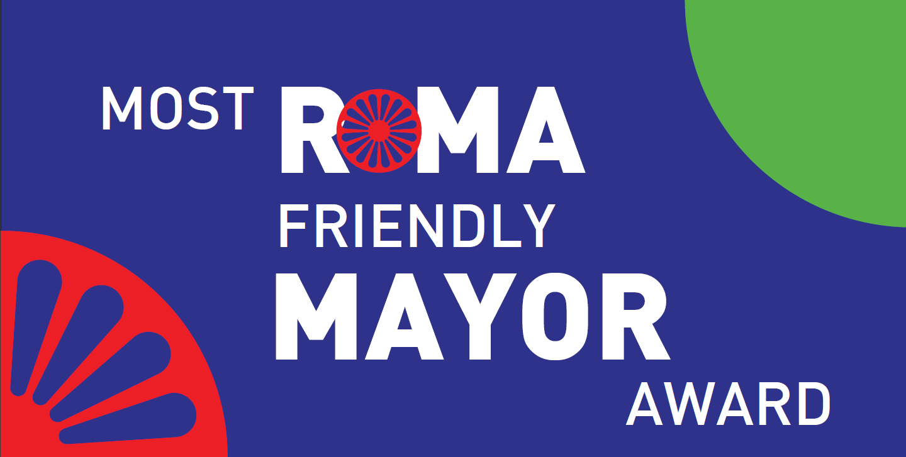
APPLICATION FORM

“Most Roma Friendly Mayor” award, 2024

1. Describe your municipality giving special attention to the Roma minority (if possible: including database info of the municipality about Roma)

2. Atmosphere: How is the interethnic atmosphere in your municipality?
- Describe points and events of encounter & dialogue between Roma and non-Roma.
- What is your contribution for that?
- How do local authorities deal with the Roma community?
- How is the level of trust between authorities and communities (looking at decision-making, implementation and collaboration)?

3. Participation & Dialogue: How do you involve and strengthen the participation of the Roma community?
- How many times has the mayor visited the Roma communities?
- Are Roma being represented in the council of the municipality?

4. Roma Strategy: What do you know about the National documents on Roma Inclusion (e.g. Strategies and action plans)?
- What have you done so far related to that and in general for the Roma community?
- Performance of the municipality: How have you fulfilled and worked with the demands of the communities (during the last mandate)?
- Finances, evaluating spending: What are the actual and future investments (plans) for the Roma minority (objective, goals and priorities of the municipality for the Roma minority)?

5. Employment: How many Roma are employed in the municipality and in what positions?
How do you promote/support Roma employment in your municipality?

6. Education: How is the school situation of Roma children and youth and what support have you given to education?

7. Housing: How is the situation of Roma related to housing in your municipality and what you have done to ensure basic access to housing?

8. Health Care: How is the health care situation of Roma and your assistance to improve it?

9. Antigypsyism: The most basic structure regarding Roma antigypsyism in your municipality, how they are structures and how do they work?

10. Why would your Roma community select you as “most Roma-friendly mayor”?

*You can increase the size of each box as it might be needed.
The application form can be mailed to: Roma Active Albania; Rr.Ylbere Bylykbashi; P. 25; Shk. 2; Ap 4; Tirane, Albania, or be sent via email to: Info@raa.al: , until February 29th 2024, local time 23:59.

Date of submission: ______________________

